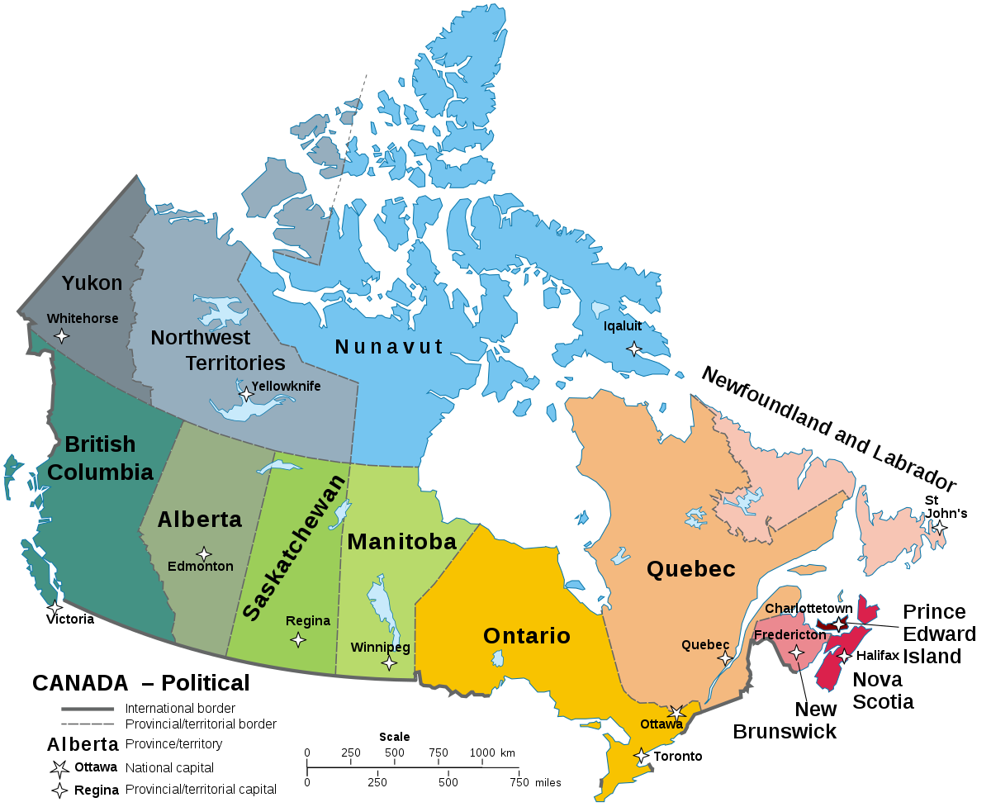

[This Photo](https://en.wikipedia.org/wiki/Provinces_and_territories_of_Canada) by Unknown Author is licensed under [CC BY-SA](https://creativecommons.org/licenses/by-sa/3.0/)

Link for the temperature:

<https://weather.gc.ca/canada_e.html>

Weather Challenge: Find a city on the map, then find the temperature of that city, then the temperature represent the number of time you have to do the activity.

Weather Challenge

|  |  |  |
| --- | --- | --- |
| City | Temperature | Activity |
|  |  |  |
|  |  | Push up |
|  |  | Jumping jacks |
|  |  | Sit ups |
|  |  | Burpees |
|  |  | Squats |
|  |  | High Knee Jumps |
|  |  | Lunges |
|  |  | Plank  Temperature represent time to perform |
|  |  | Stationary Running  Temperature represent time to perform |
|  |  | Air Boxing  Temperature represent time to perform |

Weather Challenge: Find a city on the map, then find the temperature of that city, then the temperature represent the number of time you have to do the activity.